**EXPERIMENT 3**

**RELATIONAL MODEL FOR A COLLEGE DATABASE**

**Aim**: Draw a relational model for a college database.

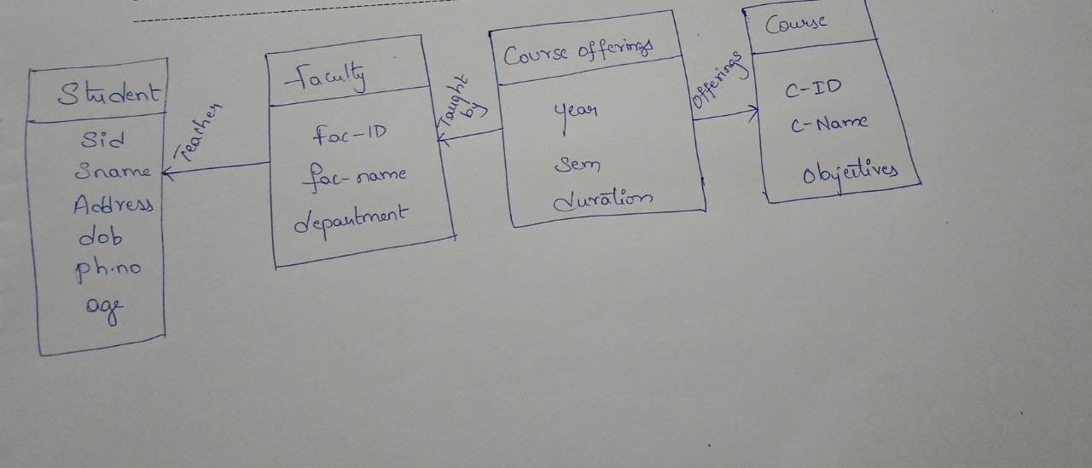

Sid

Sname

Address

Dob

PhNo

age

Fac_id

Fac_name

department

Year

Sem

duration

**Student**

**Faculty**

**Course offerings**

teaches

taught

by

**Course**

Cid

C_name

objectives

offering